# Red Regenerator app

The Red Regenerator app is designed to automatically generate and administer sales contracts. You can generate a sales contract manually, or automatically. When you post an item, general ledger Line, or resource the contract generator will automatically create a sales contract based on a template. The contract regenerator will automatically regenerate sales invoices or orders based on the contract billing period.

# Setup

The first thing we need is the Regenerator setup. The suppress sales and post commit block the post when the contract generauion fails. The number series are for the sales and purchase contracts. Then number series work like any other number series in Business Central.

## Contract Groups

Contract groups specify which types of contracts exist and how they are regenerated. The regenerate type specifies if the contract is invoice via an order or an invoice.

## Contract Template

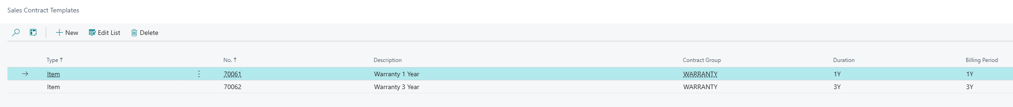

The contract template specifies how the contracts are created when you ship a sales document. The contract is created with the values you specify on this page.

## Item Contract

If you want to co sell an item with a contract then you can add an Item Contract. This is a link from an item, resource, or general ledger to a contract template. One item can have multiple contract templates.

# Generate a contract from a sales document

If you want to generate a contract from a sales document you need to create a sales document, and add an item that has a contract template. When you do this the Generate Contract checkbox will be checked. Once you post the document the contract will be created.

# Generate a sales document from a contract

If you want to generate a sales document from a contract the contract group needs to have the Regenerate Type field filled.

After you have created the contract it is not active yet, you need to activate it. Once the contract is activated the first sales document will be created. As long as the contract is not expired yet you can select regenerate. This action will create a sales document for the next billing date.

When the contract is expired you can renew it, that will renew the contract for the same billing period. You can also cancel the contract. This action will end the contract and store the contract in the Contract Archive.

